Docker task:2
1.Task: Create a Tomcat Container on Port 8080 and Deploy a Sample Application
Objective
To create an Apache Tomcat container using Docker and deploy a sample WAR application.

Step 1: Pull the Tomcat Image
docker pull tomcat

Step 2: Run the Tomcat Container
docker run -d --name tomcat-container -p 8080:8080 tomcat

Step 3: Verify the Container is Running
docker ps
Output:
CONTAINER ID IMAGE STATUS PORTS
xxxxxxxxxxxx tomcat Up ... 0.0.0.0:8080->8080/tcp

Step 4: Download the Sample WAR File
wget https://tomcat.apache.org/tomcat-7.0-doc/appdev/sample/sample.war

Step 5: Copy the WAR File into the Tomcat Container
docker cp sample.war tomcat-container:/usr/local/tomcat/webapps/

Step 6: Verify Deployment
docker exec tomcat-container ls /usr/local/tomcat/webapps
Output:
sample
sample.war

Step 7: Access the Application
Open the following URL in a browser:
http://<EC2-Public-IP>:8080/sample
The Sample "Hello, World" Application page is displayed successfully.

Commands Used
docker pull tomcat
docker run -d --name tomcat-container -p 8080:8080 tomcat
wget https://tomcat.apache.org/tomcat-7.0-doc/appdev/sample/sample.war
docker cp sample.war tomcat-container:/usr/local/tomcat/webapps/
docker exec tomcat-container ls /usr/local/tomcat/webapps

Result
✅ Successfully created an Apache Tomcat container on port 8080.
✅ Successfully deployed the sample application (sample.war) in the Tomcat container.
✅ Verified the deployment by accessing:
http://<EC2-Public-IP>:8080/sample
and displaying the Sample "Hello, World" Application page.
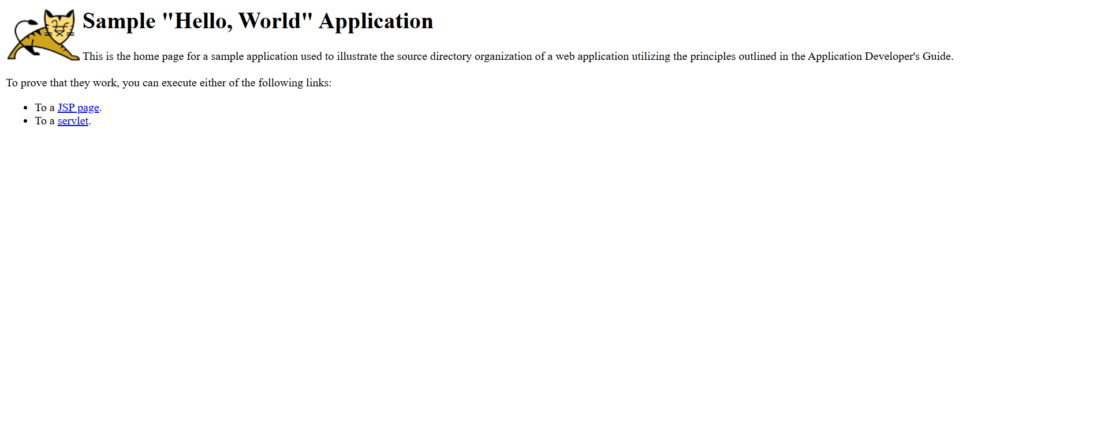

Task: Create a Docker Volume and Deploy a Tomcat Container on Port 8081
Objective
To create a Docker volume and deploy an Apache Tomcat container on port 8081 using the created volume.

Step 1: Create a Docker Volume
docker volume create tomcat-volume

Step 2: Verify the Volume
docker volume ls
Expected Output:
DRIVER VOLUME NAME
local tomcat-volume

Step 3: Run the Tomcat Container on Port 8081 with the Volume
docker run -d --name tomcat-volume-container -p 8081:8080 -v tomcat-volume:/usr/local/tomcat/webapps tomcat
Command Explanation
- -d → Run the container in detached mode.
- --name tomcat-volume-container → Name of the container.
- -p 8081:8080 → Maps EC2 port 8081 to Tomcat port 8080.
- -v tomcat-volume:/usr/local/tomcat/webapps → Mounts the Docker volume to Tomcat's webapps directory.

Step 4: Verify the Container is Running
docker ps
Expected Output:
CONTAINER ID IMAGE STATUS PORTS
xxxxxxxxxxxx tomcat Up ... 0.0.0.0:8081->8080/tcp

Step 5: Verify the Volume is Mounted
docker inspect tomcat-volume-container
Look for:
"Mounts": [
{
"Type": "volume",
"Name": "tomcat-volume",
"Destination": "/usr/local/tomcat/webapps"
}
]

Step 6: Deploy the Sample Application (Optional)
Copy the sample WAR file:
docker cp sample.war tomcat-volume-container:/usr/local/tomcat/webapps/
Verify deployment:
docker exec tomcat-volume-container ls /usr/local/tomcat/webapps
Expected Output:
sample
sample.war

Step 7: Access the Application
Tomcat Home:
http://<EC2-Public-IP>:8081
Sample Application:
http://<EC2-Public-IP>:8081/sample/

Commands Used
docker volume create tomcat-volume
docker volume ls
docker run -d --name tomcat-volume-container -p 8081:8080 -v tomcat-volume:/usr/local/tomcat/webapps tomcat
docker ps
docker inspect tomcat-volume-container
docker cp sample.war tomcat-volume-container:/usr/local/tomcat/webapps/
docker exec tomcat-volume-container ls /usr/local/tomcat/webapps

Result
✅ Successfully created a Docker volume named tomcat-volume.
✅ Successfully deployed an Apache Tomcat container on port 8081.
✅ Successfully mounted the volume to /usr/local/tomcat/webapps.
✅ Successfully deployed and accessed the sample application at:
http://<EC2-Public-IP>:8081/sample/
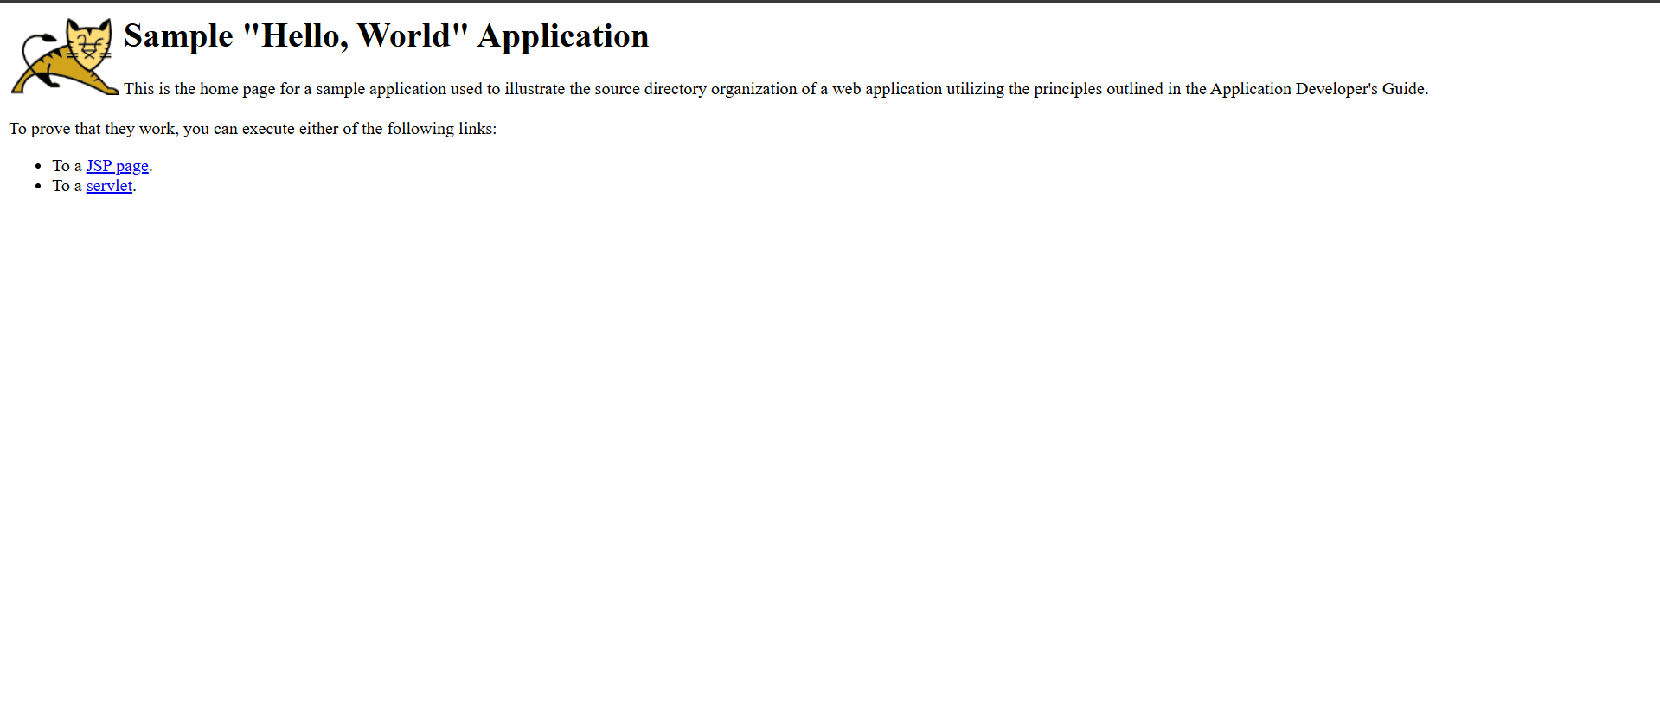

3.Task: Limit the Nginx Container to 500 MB
Objective
To deploy an Nginx container with a maximum memory limit of 500 MB.

Step 1: Pull the Nginx Image
docker pull nginx

Step 2: Run the Nginx Container with a 500 MB Memory Limit
docker run -d --name nginx-limit-container -p 82:80 --memory="500m" nginx

Step 3: Verify the Container is Running
docker ps
Output:
CONTAINER ID IMAGE STATUS PORTS
xxxxxxxxxxxx nginx Up ... 0.0.0.0:82->80/tcp

Step 4: Verify the Memory Limit
docker inspect nginx-limit-container --format='{{.HostConfig.Memory}}'
Output:
524288000
(524,288,000 bytes = 500 MB)

Step 5: Access the Nginx Application
Open:
http://<EC2-Public-IP>:82

Result
✅ Successfully deployed an Nginx container.
✅ Limited the container memory to 500 MB using the --memory="500m" option.
✅ Verified the memory limit using docker inspect.
✅ Verified that the container is running successfully on port 82.
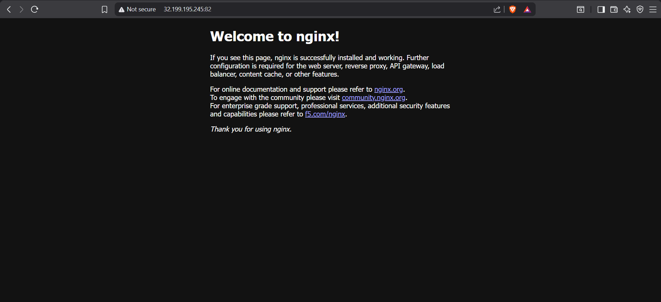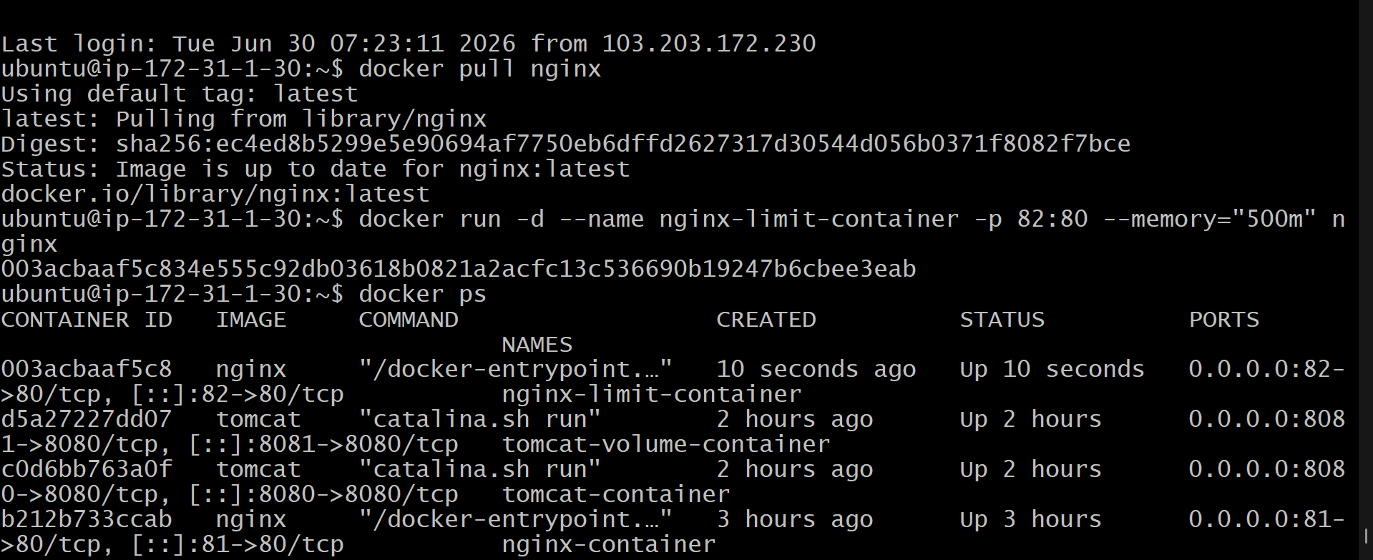

4.Docker Nginx Setup – Step by Step Guide
1. Create a Project Directory
Open terminal and create a folder:
mkdir nginx-project
cd nginx-project

2. Create Dockerfile
Create a file named Dockerfile:
nano Dockerfile
Paste the below content:
FROM amazonlinux:latest

LABEL maintainer="Varun Dalal"

RUN yum update -y && yum install -y nginx

COPY index.html /usr/share/nginx/html/index.html

EXPOSE 80

CMD ["nginx", "-g", "daemon off;"]
Save and exit:
- Press CTRL + X
- Press Y
- Press Enter

3. Create index.html file
nano index.html
Paste this content:
<!DOCTYPE html>
<html>
<head>
<title>My Nginx Docker</title>
</head>
<body>
<h1>Welcome to My Docker Nginx Container</h1>
</body>
</html>
Save and exit.

4. Build Docker Image
docker build -t my-nginx-image .

5. Run Docker Container
docker run -d -p 80:80 --name nginx-container my-nginx-image

6. Check Running Container
docker ps

7. View Logs (Optional)
docker logs nginx-container

8. Access in Browser
Open browser and enter:
http://<your-server-ip>
Example:
http://54.23.12.45

✅ Expected Output
You should see:
Welcome to My Docker Nginx Container

🎯 Conclusion
You have successfully:
- Created a Dockerfile
- Built a Docker image
- Run an Nginx container
- Hosted a web page using Docker

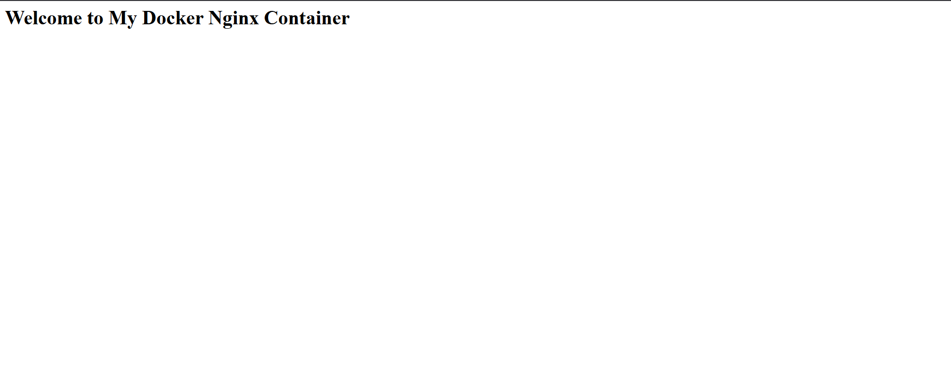

5.Push image to Docker hub
Step 1: Login to Docker Hub
Run the following command:
docker login
👉 Enter:
- Username: your Docker Hub username
- Password: your Docker Hub password
If successful, you will see:
Login Succeeded

📦 Step 2: Build Docker Image
Go to your project directory where Dockerfile is present:
cd ~/nginx-project
Build the image:
docker build -t my-nginx-image .
✔ This creates a local Docker image named my-nginx-image

🏷️ Step 3: Tag Docker Image
Docker Hub requires images in this format:
<dockerhub-username>/<image-name>:tag
Tag the image:
docker tag my-nginx-image varun1710/my-nginx-image:v1

🚀 Step 4: Push Image to Docker Hub
Push the image:
docker push varun1710/my-nginx-image:v1

📤 Step 5: Verify Upload
After successful push, you will see output like:
digest: sha256:xxxxxxxx
size: xxxx

🌐 Step 6: Check on Docker Hub
Open your browser and go to:
https://hub.docker.com/r/varun1710/my-nginx-image
You should see:
- Repository created
- Tag: v1
- Image uploaded successfully

🎯 Final Result
✔ Docker image built successfully
✔ Image tagged correctly
✔ Image pushed to Docker Hub
✔ Image available for pull & deployment

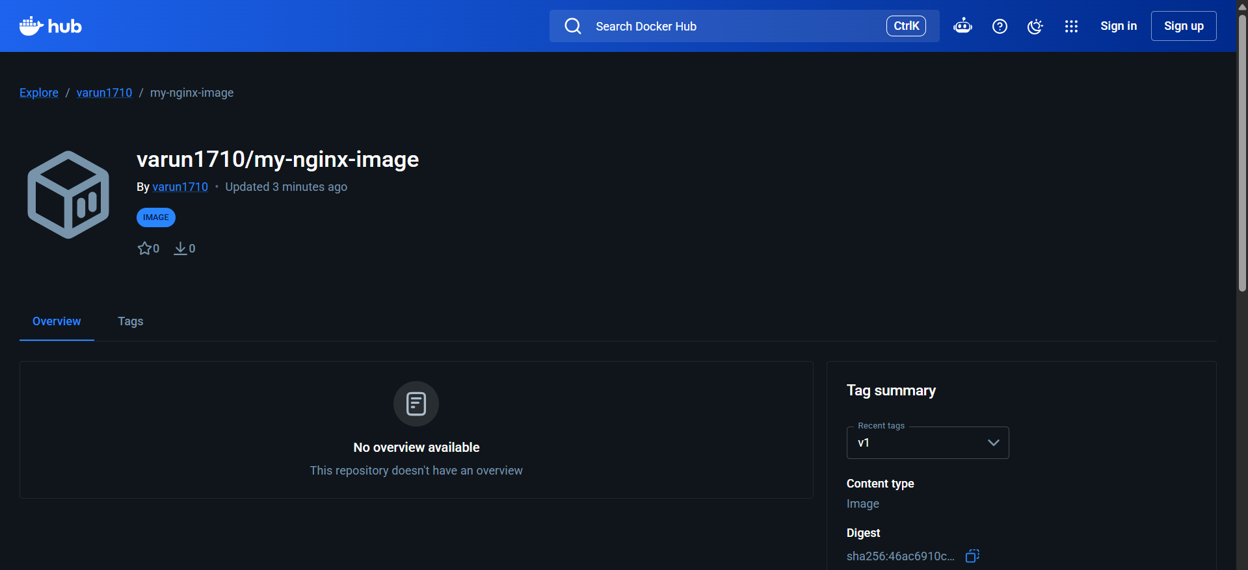

6.Task: Push Docker Image to AWS ECR
Objective
Push the Docker image my-nginx-image to AWS Elastic Container Registry (ECR).

Prerequisites
- AWS Account
- IAM User with AmazonEC2ContainerRegistryFullAccess permission
- AWS CLI installed
- Docker installed
- Docker image my-nginx-image already created

Step 1: Configure AWS CLI
aws configure
Enter the following details:
AWS Access Key ID: <YOUR_ACCESS_KEY>
AWS Secret Access Key: <YOUR_SECRET_KEY>
Default region name: us-east-1
Default output format: json

Step 2: Verify AWS Configuration
aws sts get-caller-identity

Step 3: Create an ECR Repository
aws ecr create-repository --repository-name my-nginx-image --region us-east-1

Step 4: Login Docker to AWS ECR
aws ecr get-login-password --region us-east-1 | docker login --username AWS --password-stdin 610140802141.dkr.ecr.us-east-1.amazonaws.com
Expected Output:
Login Succeeded

Step 5: Verify Docker Image
docker images
Ensure the image my-nginx-image is present.

Step 6: Tag the Docker Image
docker tag my-nginx-image:latest 610140802141.dkr.ecr.us-east-1.amazonaws.com/my-nginx-image:latest

Step 7: Push the Docker Image to AWS ECR
docker push 610140802141.dkr.ecr.us-east-1.amazonaws.com/my-nginx-image:latest

Step 8: Verify the Image in ECR
aws ecr list-images --repository-name my-nginx-image --region us-east-1

Step 9: Verify in AWS Console
- Login to AWS Console.
- Navigate to Amazon ECR.
- Click Repositories.
- Open my-nginx-image repository.
- Verify that the image tag latest is present and the status is Active.

Final Image URI
610140802141.dkr.ecr.us-east-1.amazonaws.com/my-nginx-image:latest
Result
The Docker image my-nginx-image was successfully pushed to AWS Elastic Container Registry (ECR).
